EX. NO: 3

IMPLEMENTATION OF HILL CIPHER
Aim:
To write a C program to implement the hill cipher substitution techniques.
ALGORITHM:
STEP-1: Read the plain text and key from the user.
STEP-2: Split the plain text into groups of length three.
STEP-3: Arrange the keyword in a 3*3 matrix.
STEP-4: Multiply the two matrices to obtain the cipher text of length three.
STEP-5: Combine all these groups to get the complete cipher text.
Program:
#include <stdio.h>
int main()
{
int key[2][2], text[2], cipher[2];
char msg[3];
int i, j;
printf("Enter 2-letter message (A-Z): ");
scanf("%s", msg);
printf("Enter 2x2 key matrix:\n");
for(i = 0; i < 2; i++)
{
for(j = 0; j < 2; j++)
{
scanf("%d", &key[i][j]);
}
}
// Convert letters to numbers
text[0] = msg[0] - 'A';
text[1] = msg[1] - 'A';
// Encryption
for(i = 0; i < 2; i++)
{
cipher[i] = 0;
for(j = 0; j < 2; j++)
{
cipher[i] += key[i][j] * text[j];
}
cipher[i] = cipher[i] % 26;
}
printf("Encrypted Message: ");
printf("%c%c", cipher[0] + 'A', cipher[1] + 'A');
return 0;
}
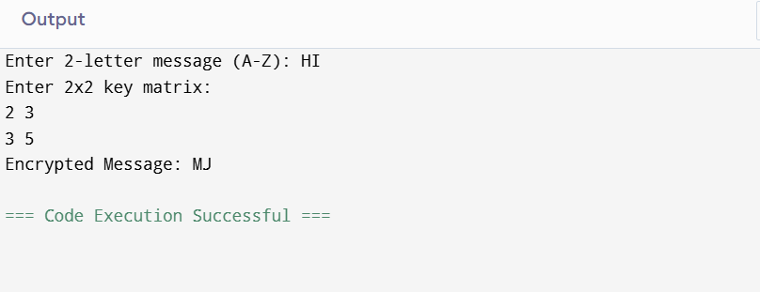
Result:
Thus the hill cipher substitution technique had been implemented successfully in C.
‘’

